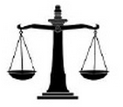
12 Angry Men Character Log

As you read the play, keep track of one of the jurors. What do we learn about them? What biases do they have? How do they influence the other characters?

Your Character:

What do we learn about this character in…
Act I | Act II | Act III

In each of the whole-group votes, how did your character vote? If their vote changed, what reason does your character give?

Vote 1 (Opening) | Vote 2 (Private Ballot) | Vote 3 (Beginning Act III) | Vote 4 (Mid-Act III)

If your character changes their vote at any other time, what reason do they give for doing so?

