**Twelve Angry Men**

**by Reginald Rose**

**Study Guide**

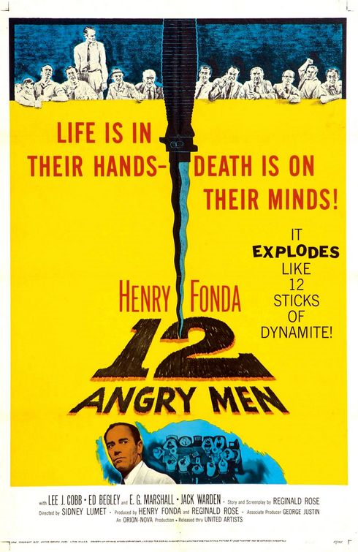

http://theinvisibleagent.files.wordpress.com/2009/03/twelve_angry_men.jpg

**Name_______________________________________________ #: ________ Class Period: _________**

**THE JURORS**

|  |  |  |  |
| --- | --- | --- | --- |
| **Character** | |  | **Description** |
| JUROR 1  the Foreman |  |  | |
| JUROR 2  the Mouse |  |  | |
| JUROR 3  the Bad Dad |  |  | |
| JUROR 4  the Stockbroker |  |  | |
| JUROR 5  the Kid from the Slums |  |  | |
| JUROR 6  the Working Turtle |  |  | |
| JUROR 7  the Bully |  |  | |
| JUROR 8  the Fair Architect |  |  | |
| JUROR 9  the Old Man |  |  | |
| JUROR 10  the Bigot |  |  | |
| JUROR 11  the Immigrant |  |  | |
| JUROR 12  the Ad Man |  |  | |

**KEEPING TRACK OF TESTIMONIES**

|  |  |
| --- | --- |
| **Witness Testimony** | **Is it credible?** |
| Old man downstairs |  |
| The kid |  |
| Lady across the el tracks |  |
| Couple across hall from kid’s apartment |  |
| Movie theater workers |  |
| The kid’s friends |  |
| The junk shop owner |  |

|  |  |  |
| --- | --- | --- |
| **Jury Vote #** | **Guilty Votes – List Jury #s** | **Not Guilty Votes – List Jury #s** |
| 1 |  |  |
| 2 |  |  |
| 3 |  |  |
| 4 |  |  |
| 5 |  |  |
| 6 |  |  |
| 7 |  |  |
| 8 |  |  |

**EVIDENCE TRACKING CHART for *Twelve Angry Men***

|  |  |  |
| --- | --- | --- |
| **Evidence** | **Argument in Favor of Guilty** | **Argument in Favor of Not Guilty** |
| **Motive** |  |  |
| **Knife** |  |  |
| **Witness 1**  **Woman across the street** |  |  |
| **Witness 2**  **Man who lived on 2nd floor** |  |  |
| **Alibi** |  |  |
| **Stab Wound** |  |  |

**TIMELINE OF EVENTS**

**ON THE NIGHT OF THE MURDER**