

|  |
| --- |
| Macbeth Act 2 |

|  |  |
| --- | --- |
| **Scene summaries** | |
| Subject: | **English** |
| Age range: | **10–12, 12–14** |
| Topic: | **Macbeth** |

EAL Nexus resource

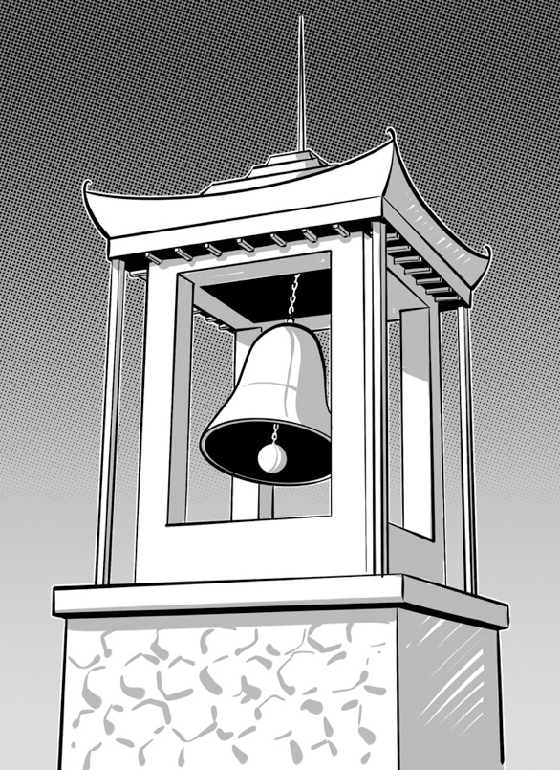

This project and its actions were made possible due to co-financing by the European Fund for the Integration of Third-Country Nationals.

This project and its actions were made possible due to co-financing by the European Fund for the Integration of Third-Country Nationals.

This project and its actions were made possible due to co-financing by the European Fund for the Integration of Third-Country Nationals.



# Macbeth Act 2

## **Scene 1 Macbeth’s castle at Inverness**

Banquo is talking to his son, Fleance. Banquo cannot sleep because he is worried about the witches and their prophecies.

Macbeth arrives. Banquo tells him that he has been dreaming about the witches and their prophecies. Macbeth does not want to talk to Banquo about it, and tells Banquo he does not think about the witches. Banquo and Fleance leave.

Macbeth is alone again. He thinks about killing Duncan. He imagines he can see a dagger with blood on it in front of him. He hears a bell ring in the bell tower. Then he goes to murder Duncan.

## **Key words or phrases with pictures**

the bell the bell tower

sunset three witches Macbeth

## **Key words to translate**

| **Word or phrase** | **Translation** | **Meaning** |
| --- | --- | --- |
| to dream |  |  |
| to hear |  |  |
| in front of |  |  |
| to imagine |  |  |
| to sleep |  |  |
| to think about |  |  |
| worried |  |  |

## **Scene 2 Macbeth’s castle at Inverness**

## Lady Macbeth waits for her husband to come back. She is worried that he might not have killed Duncan. Macbeth arrives and tells her he has killed Duncan. He is very upset and agitated. Macbeth has blood on his hands and Lady Macbeth tells him to wash it off. She sees that he has got the daggers he used to kill Duncan and she tells him to take them back to the king’s room. Macbeth does not want to go back into the room. Lady Macbeth takes the daggers back herself and smears blood on the grooms’ faces.

Someone knocks loudly at the gate of the castle. Macbeth and Lady Macbeth go to wash off the blood and to get into their nightclothes.

## **Key words or phrases with pictures**

the gate the castle

## **Key words to translate**

| **Word or phrase** | **Translation** | **Meaning** |
| --- | --- | --- |
| agitated |  |  |
| to knock loudly |  |  |
| nightclothes |  |  |
| upset |  |  |
| to use |  |  |
| to wait |  |  |
| to wash off |  |  |

**Scene 3 Macbeth’s castle at Inverness**

A porter goes to see who is knocking at the castle gate. He is drunk. He opens the gate. It is Macduff and Lennox who were knocking. They have come to see Duncan.

Macbeth arrives. He takes Macduff and Lennox to the king’s bedroom. Macduff goes in and finds Duncan is dead. Macduff comes back and tells everyone about the murder.

Lady Macbeth, Banquo, Malcolm and Donalbain come in. Macbeth pretends to be very angry and upset about Duncan’s death and goes and kills the two grooms. Lady Macbeth faints.

Malcolm and Donalbain realise that they are in danger. They decide to run away. Malcolm decides to go to England and Donalbain to Ireland.

## **Key words or phrases with pictures**

the two grooms

## **Key words to translate**

| **Word or phrase** | **Translation** | **Meaning** |
| --- | --- | --- |
| angry |  |  |
| to faint |  |  |
| to find |  |  |
| porter |  |  |
| to pretend |  |  |
| to run away |  |  |

**Scene 4 Outside Macbeth’s castle at Inverness**

Ross and an old man talk about the murder. Macduff arrives and says that most people think that the grooms killed Duncan. He says that Malcolm and Donalbain paid the grooms to kill their father and that is why they ran away.

Macduff says that Macbeth will be the next king. Macbeth has gone to Scone to be crowned king. Macduff is not going to Scone; he is going home.

## **Key words to translate**

| **Word or phrase** | **Translation** | **Meaning** |
| --- | --- | --- |
| to be crowned |  |  |
| to pay |  |  |
| Scone |  | The place in Scotland where kings and queens are crowned. |