

|  |
| --- |
| Macbeth Act 3 |

|  |  |
| --- | --- |
| **DARTs activities** | |
| **Subject:** | **English** |
| **Age range:** | **10–12, 12–14** |
| **Topic:** | **Macbeth** |

EAL Nexus resource

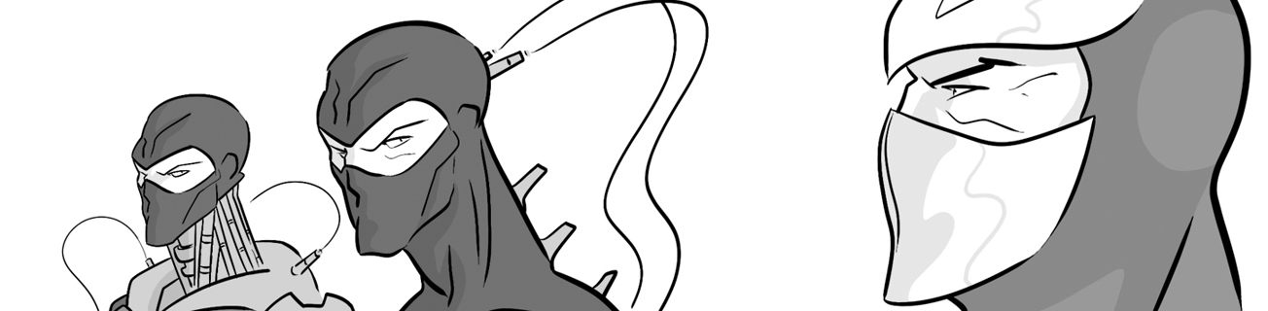

This project and its actions were made possible due to co-financing by the European Fund for the Integration of Third-Country Nationals.

This project and its actions were made possible due to co-financing by the European Fund for the Integration of Third-Country Nationals.

This project and its actions were made possible due to co-financing by the European Fund for the Integration of Third-Country Nationals.



**Act Three: Scene 1**

**Macbeth and Banquo**

Which thoughts belong to Macbeth and which to Banquo? Fill in the table below.

The witches said my sons will be kings.

I think he was involved in Duncan’s murder.

I think he suspects me of killing Duncan.

It’s strange that the witches said he would be king and now he is.

I won’t be safe until he is dead.

|  |  |
| --- | --- |
| **Macbeth’s thoughts** | **Banquo’s thoughts** |
|  |  |

**Act Three: Scene 2**

**Feelings and actions**

Fill in the grid showing Macbeth and Lady Macbeth’s feelings and actions in this scene.

|  |  |  |
| --- | --- | --- |
|  | Macbeth | Lady Macbeth |
| Feelings |  |  |
| Actions |  |  |

tries to calm her husband down upset

warns his wife that something terrible will happen that night

frightened arranges for Banquo and Fleance to be murdered

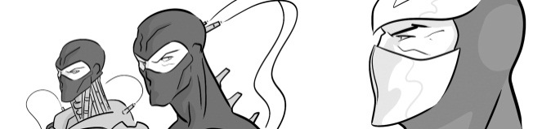**Act Three: Scene 3**

**Active and passive**

Turn these active sentences into the passive. The first one has been done for you.

1. A third murderer joins the two murderers.

The two murderers are joined by a third murderer.

1. Macbeth sends the third murderer.

The third murderer _______________ Macbeth.

1. The three murderers attack Banquo and Fleance.

______________________________________________

1. The murderers kill Banquo.

_______________________________________________

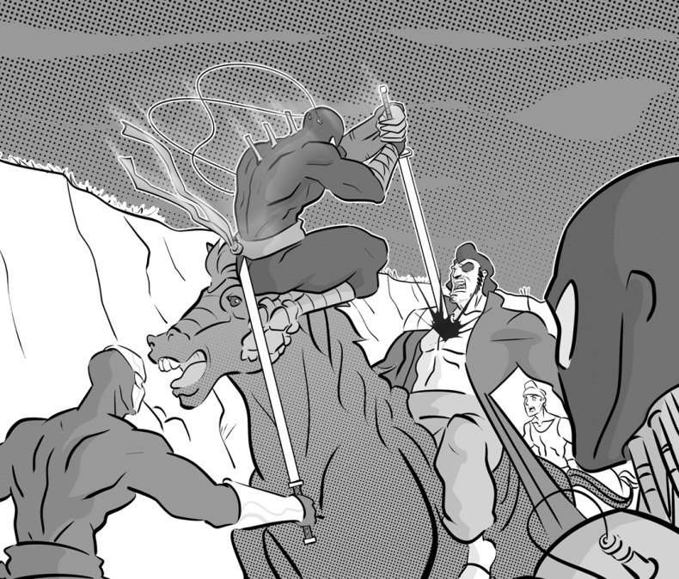

**Act Three: Scene 4**

**Comparing Macbeth and Lady Macbeth**

Fill in the Venn diagram to show which words and phrases from the box below describe Macbeth, Lady Macbeth or both of them.



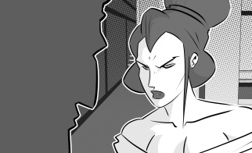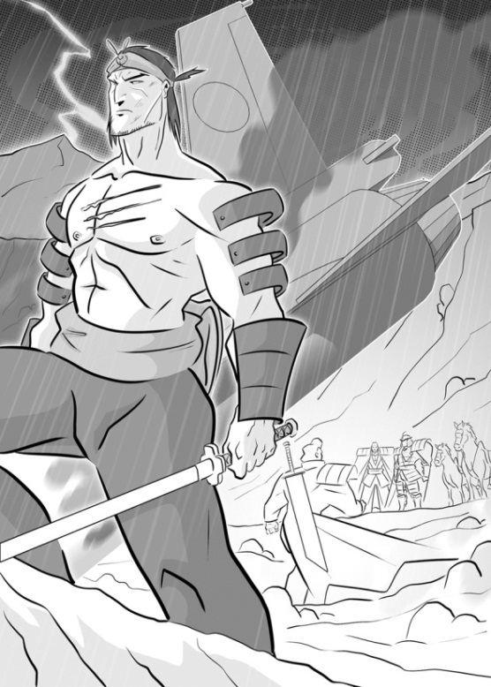

Lady Macbeth

Macbeth

have a feast for the noblemen can see Banquo’s ghost can’t see Banquo’s ghost welcome their guests gets a message that Banquo is dead talks to the ghost terrified

worried about what their guests will think does not trust the Scottish noblemen sends the guests away

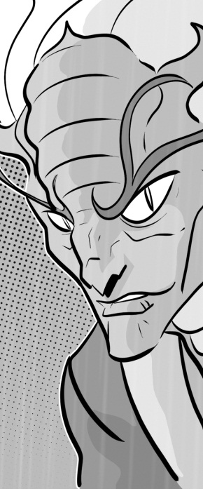**Act Three: Scene 5**

**Questions about Hecate**

Fill in the correct ‘wh’ word in these questions about Hecate.

Q: _______ is Hecate?

A: Hecate is the queen of the witches.

Q: _______ does Hecate meet the three witches?

A: Hecate meets the three witches on the heath.

Q: _________ is Hecate angry?

A: She is angry because the other witches talked to Macbeth without involving her.

Q: ___________ does Hecate tell the witches to do?

A: She tells the three witches to get ready to meet Macbeth.

Q: ___________ does Hecate tell the witches to meet Macbeth?

A: She tells the three witches to meet Macbeth the next day.

**Act Three: Scene 6**

Where? Why? When? Who? What?

**Which character?**

Match the character with the description.

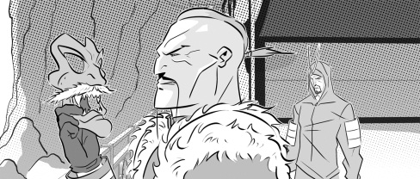

Macbeth is …

Duncan was …

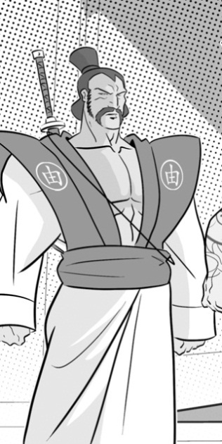

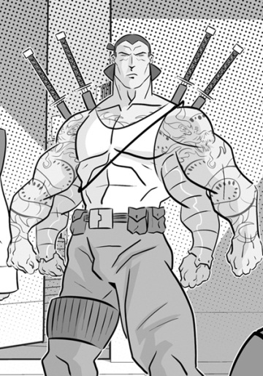

Macduff is …

Lennox is …

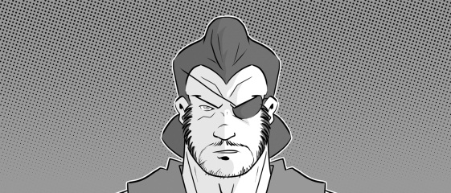

Banquo was …

… a Scottish nobleman who suspects Macbeth was involved in the murders of Duncan and Banquo.

... the previous King of Scotland who was murdered by Macbeth.

… a Scottish nobleman who was murdered by three men sent by Macbeth.

… a tyrant.

… a Scottish nobleman who has gone to ask the King of England to fight against Macbeth.