

EAL Nexus resource

|  |
| --- |
| Macbeth Act 5 |

|  |  |
| --- | --- |
| **DARTs activities** | |
| **Subject:** | **English** |
| **Age range:** | **10–12, 12–14** |
| **Topic:** | **Macbeth** |

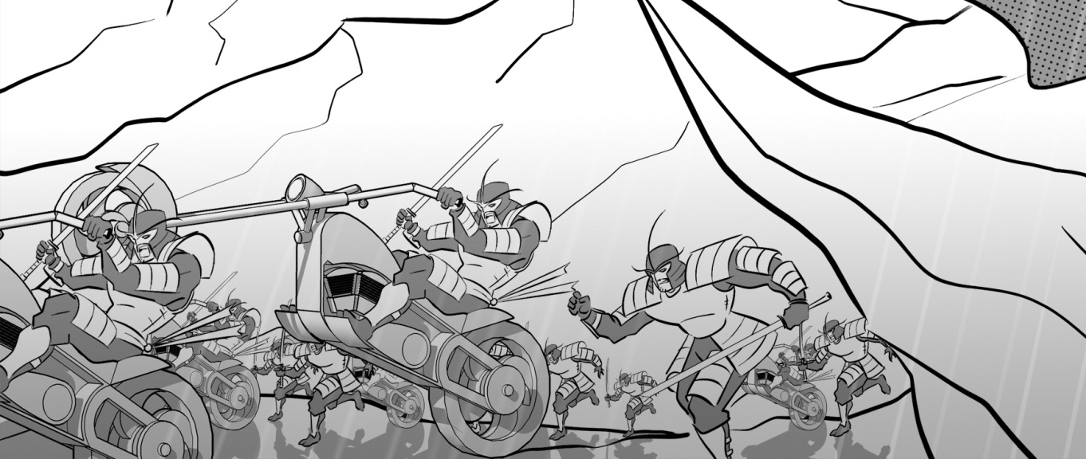



This project and its actions were made possible due to co-financing by the European Fund for the Integration of Third-Country Nationals.

This project and its actions were made possible due to co-financing by the European Fund for the Integration of Third-Country Nationals.

This project and its actions were made possible due to co-financing by the European Fund for the Integration of Third-Country Nationals.

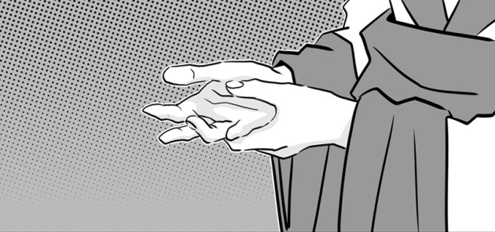**Act Five: Scene 1**

**Lady Macbeth sleepwalks**

Choose the correct connective to link the sentence halves together.

because about

|  |  |  |
| --- | --- | --- |
| The lady-in-waiting has called the doctor |  | she is worried about Lady Macbeth’s sleepwalking. |
|  |  |  |
| Lady Macbeth is talking in her sleep |  | Duncan, Banquo, Lady Macduff and her children. |
|  |  |  |
| Lady Macbeth rubs her hands together |  | she thinks she is washing blood off them. |
|  |  |  |
| Lady Macbeth feels guilty |  | the murders of Duncan, Banquo and Macduff’s family. |
|  |  |  |
| The doctor says he cannot help |  | she needs to talk to a priest. |

**Describing Lady Macbeth**

Choose three of the phrases in the box below that you think best describe Lady Macbeth in this scene.

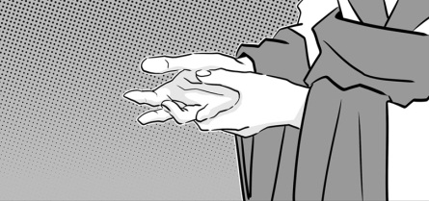

_______________________

_______________________

_______________________

restless and agitated triumphant absolutely terrified

strong and powerful driven mad by guilt

tormented by guilt calm and peaceful unable to sleep

Now write three sentences about Lady Macbeth using the phrases you chose.

1. In this scene Lady Macbeth __________________________

_______________________________________________

1. It is clear that she ________________________________

_______________________________________________

1. She seems ______________________________________

_______________________________________________

**Act Five: Scenes 2, 3 and 4**

**Macbeth and Malcolm**

Fill in the grid to show Macbeth and Malcolm’s thoughts and actions in these scenes.

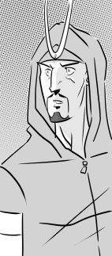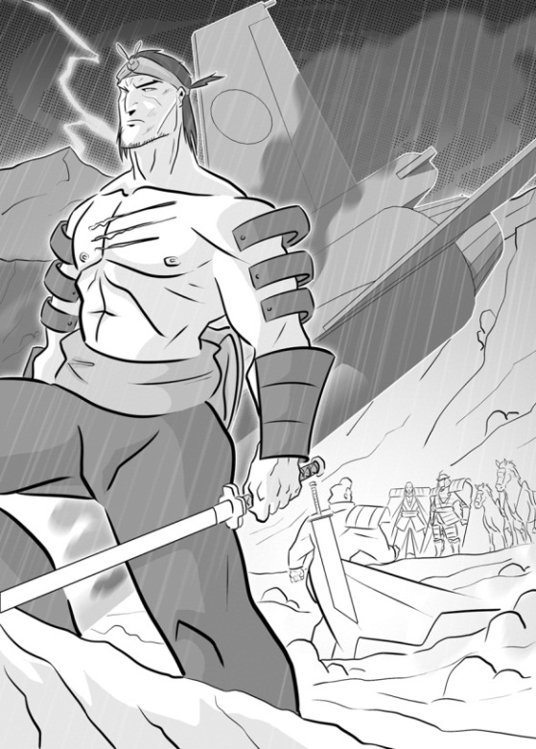

|  |  |
| --- | --- |
| Macbeth’s actions | Malcolm’s actions |
| Macbeth’s thoughts | Malcolm’s thoughts |

waits in his castle

the witches said no man born of a woman can harm me

asks the doctor how his wife is

my enemies are near

the Scottish noblemen want me to win

gathers his army near Birnam Wood

meets Scottish noblemen

I won’t be defeated until Birnam Wood comes to Dunsinane Hill

sends Seyton to get his armour

I don’t want him to know how big my army is

**Act Five: Scene 5**

**Macbeth’s decision**

Fill the gaps using the time words and phrases in the box.

then at the beginning until

after that at the end

______________ of the scene Macbeth decides to stay in his castle ___________ his enemies give up and go home. _________ Seyton comes in and tells him that his wife is dead.

___________ a messenger arrives and tells Macbeth that he can see Birnam Wood moving towards Dunsinane Hill.

____________ of the scene Macbeth decides to leave the castle and go and fight his enemies.

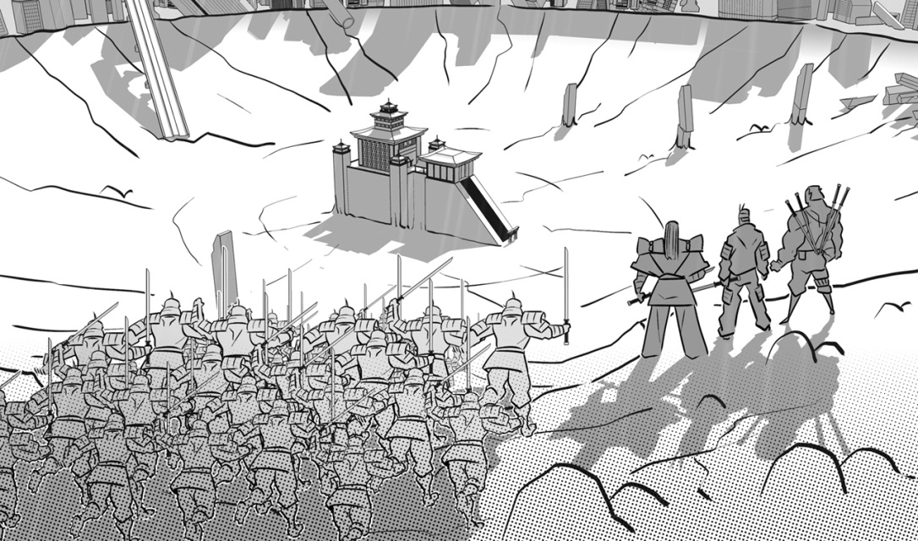

**Act Five: Scenes 6, 7, 8 and 9**

**The battle**

Put the events in order to tell the story of the battle.

The people in Macbeth’s castle surrender.

Malcolm tells his army to throw down their tree branches and begin to fight.

Macbeth tells Macduff that he can’t be harmed by any man born of a woman.

Macduff kills Macbeth.

Macduff comes in holding Macbeth’s severed head.

Macbeth kills Young Siward.

Malcolm says that now Macbeth is dead Scotland can be free again.

Macduff finds Macbeth.

Old Siward hears the news of his son’s death.

Macduff tells Macbeth he was born by Caesarean section.

Macduff greets Malcolm as King of Scotland.

tells his soldiers to cut down tree branches and carry them