

|  |
| --- |
| Macbeth Act 2 |

|  |  |
| --- | --- |
| **DARTs activities** | |
| **Subject:** | **English** |
| **Age range:** | **10–12, 12–14** |
| **Topic:** | **Macbeth** |

EAL Nexus resource

This project and its actions were made possible due to co-financing by the European Fund for the Integration of Third-Country Nationals.

This project and its actions were made possible due to co-financing by the European Fund for the Integration of Third-Country Nationals.

This project and its actions were made possible due to co-financing by the European Fund for the Integration of Third-Country Nationals.

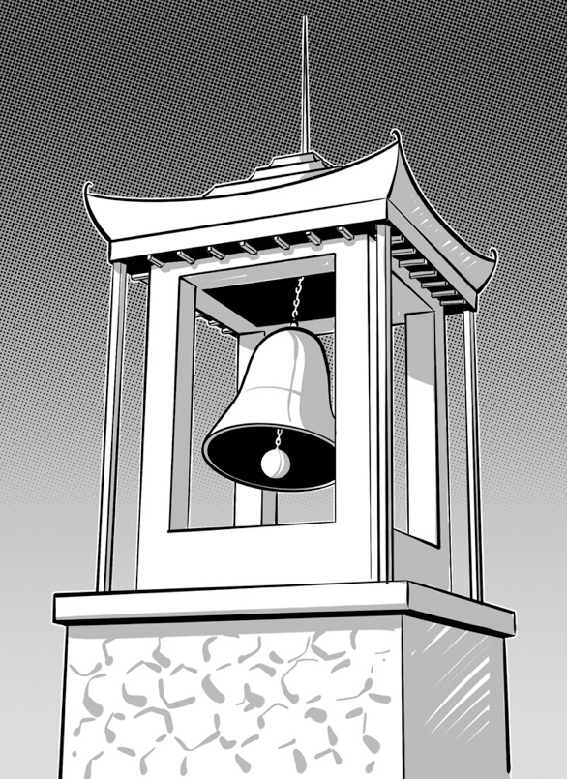

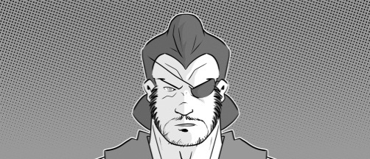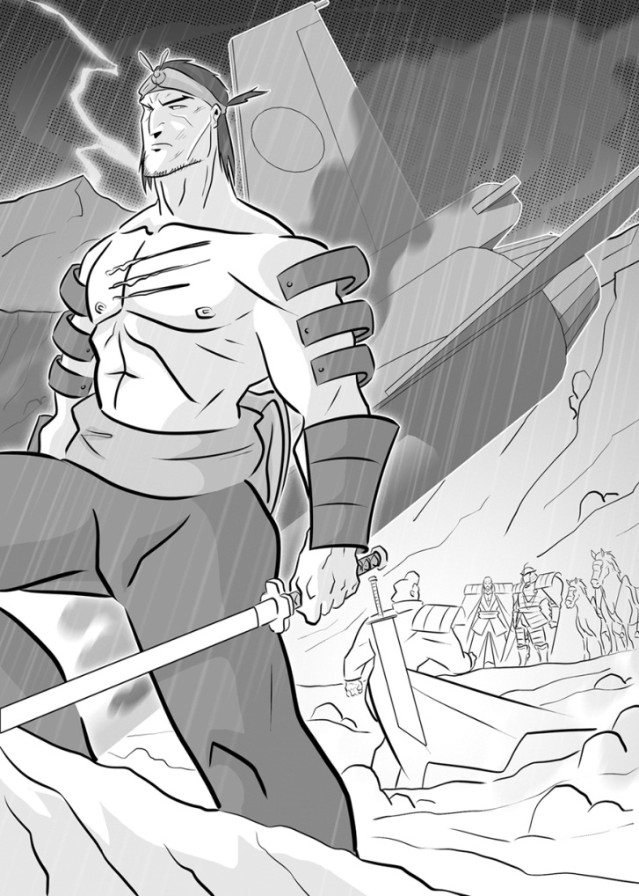**Act Two: Scene 1**

**Matching the sentence halves**

Join the two sentence halves with ‘because’ to make a compound sentence that explains what Macbeth and Banquo say and do in this scene.

|  |  |  |
| --- | --- | --- |
| Macbeth tells Banquo he does not think about the witches | **because** | he is going to Duncan’s room to kill him. |
|  |  |
| Banquo tells Fleance he cannot sleep | he is worried about the witches and their prophecies. |
|  |  |
| Macbeth imagines he can see a dagger covered with blood | he does not want to talk to him about their prophecies. |
|  |  |
| When the bell rings, Macbeth goes into the castle | he is worrying about killing Duncan. |

1. _______________________________________________

_______________________________________________

1. _______________________________________________

_______________________________________________

1. _______________________________________________

_______________________________________________

1. _______________________________________________

_______________________________________________

**Act Two: Scene 2**

**Macbeth or Lady Macbeth?**

Fill in the Venn diagram to show which words and phrases from the box below describe Macbeth, Lady Macbeth or both of them.

very upset blood on his hands brings the daggers out of the king’s room takes charge

takes the daggers back smears blood on the grooms panics

keeps calm wash off the blood put on nightclothes won’t go back into the king’s room

Macbeth

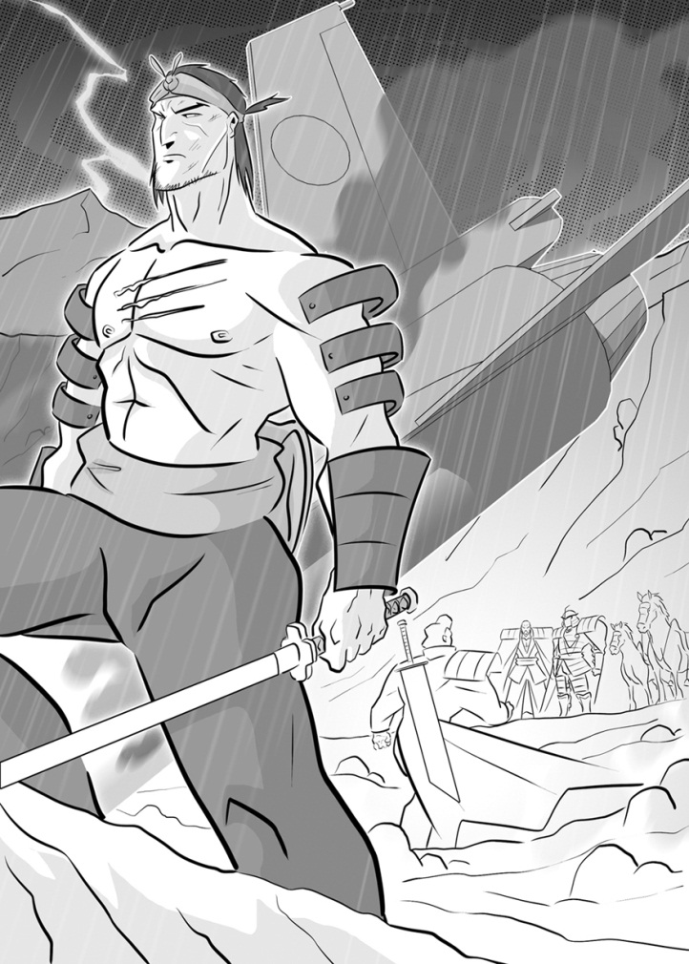

Lady Macbeth

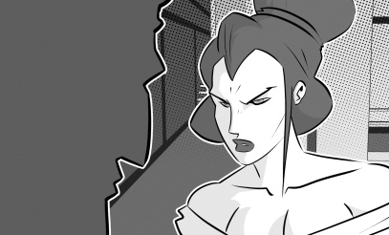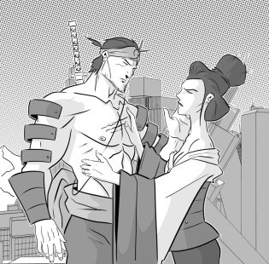

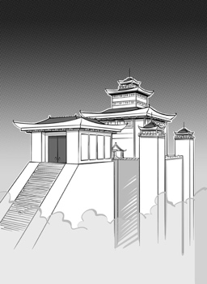**Act Two: Scene 3**

**Flow chart**

Put the main events of the scene in order to make a flow chart. You can use some of the suggestions below or write your own.

\\\\\\\\\\\\\\\\

Macduff and Lennox arrive at the castle.

|  |  |  |
| --- | --- | --- |
| Malcolm runs away to England, | Lady Macbeth faints. | Donalbain goes to Ireland. |
| The porter opens the gate. | Macduff finds the king’s body. | Macbeth arrives at the gate. |
| Lady Macbeth and Banquo come in with Malcolm and Donalbain. | Macbeth pretends to be angry. | Macbeth takes them to the king’s room. |
| He tells everyone Duncan is dead. |

**Act Two: Scene 4**

**Macbeth’s coronation**

Put a tick (✓) by the true statements and a cross (×) by the false ones.

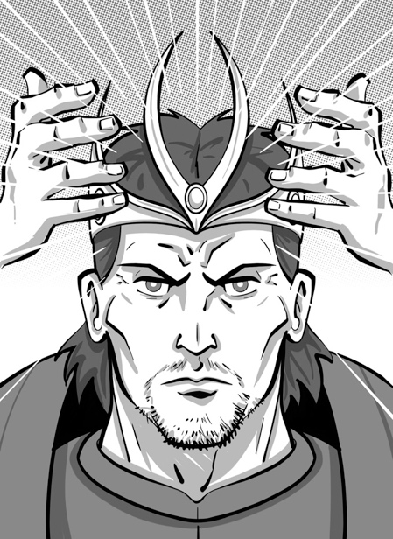

|  |  |
| --- | --- |
|  | **True (✓) or false (×)?** |
| Macbeth’s coronation will be at Scone. |  |
| Malcolm and Donalbain went to Macbeth’s coronation. |  |
| After his coronation Macbeth will be King of Scotland. |  |
| After Macbeth’s coronation another of the witches’ prophecies will have come true. |  |
| Most people at the coronation know that Macbeth killed Duncan. |  |
| Macduff is not going to Macbeth’s coronation. |  |
| When Macbeth becomes king, Lady Macbeth will be queen. |  |