

|  |
| --- |
| Macbeth Act 3 |

|  |  |
| --- | --- |
| **Scene summaries** | |
| Subject: | **English** |
| Age range: | **10–12, 12–14** |
| Topic: | **Macbeth** |

EAL Nexus resource

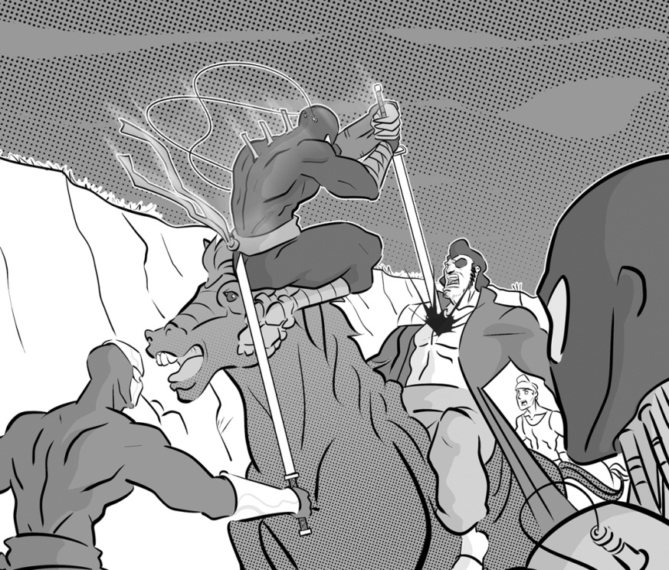

This project and its actions were made possible due to co-financing by the European Fund for the Integration of Third-Country Nationals.

This project and its actions were made possible due to co-financing by the European Fund for the Integration of Third-Country Nationals.

This project and its actions were made possible due to co-financing by the European Fund for the Integration of Third-Country Nationals.



# Macbeth Act 3

## **Scene 1 Macbeth’s palace at Forres**

Banquo is thinking about the witches and their prophecies. He suspects that Macbeth was involved in Duncan’s murder. Banquo also thinks about the witches’ prophecy that his sons will be kings.

Macbeth and Lady Macbeth come in. Macbeth is now the king and Lady Macbeth is the queen. Macbeth talks to Banquo and finds out that Banquo and his son, Fleance, are going riding that day. Macbeth realises that Banquo suspects him of being involved in the murder. Macbeth tells two murderers to kill Banquo and Fleance.

## **Key words or phrases with pictures**

Macbeth is now king and Lady Macbeth is the queen.

two murderers

sunset three witches Macbeth

## **Key words to translate**

| **Word or phrase** | **Translation** | **Meaning** |
| --- | --- | --- |
| to be involved in |  |  |
| to find out |  |  |
| to go riding |  |  |
| to suspect |  |  |

## **Scene 2 Macbeth’s palace at Forres**

Macbeth and Lady Macbeth are both agitated and frightened. Lady Macbeth tries to calm her husband down. Macbeth tells Lady Macbeth that a terrible thing will happen that night, but he does not tell her that he has sent two murderers to kill Banquo and Fleance.

**Key words to translate**

| **Word or phrase** | **Translation** | **Meaning** |
| --- | --- | --- |
| to calm down |  |  |
| frightened |  |  |
| to happen |  |  |
| a terrible thing |  |  |

**Scene 3 A park near Macbeth’s palace at Forres**

The two murderers are waiting for Banquo and Fleance. A third murderer joins them. He says Macbeth has sent him.

Banquo and Fleance arrive. The murderers attack them and kill Banquo. Fleance runs away.

**Key words to translate**

| **Word or phrase** | **Translation** | **Meaning** |
| --- | --- | --- |
| to attack |  |  |
| to join |  |  |

**Scene 4 Macbeth’s palace at Forres**

Macbeth and Lady Macbeth are having a feast. They welcome their guests. One of the murderers arrives and tells Macbeth that they have killed Banquo but Fleance has run away.

Macbeth can see Banquo’s ghost sitting at the table. Nobody else can see the ghost. Macbeth is terrified. He talks to the ghost. Lady Macbeth is worried about what their guests will think of Macbeth’s strange behaviour. She tells everybody he is ill, and they all go home.

Macbeth tells Lady Macbeth that he does not trust all the Scottish noblemen and he has spies in all their houses. He is worried about Macduff because he did not come to the feast. Macbeth decides to go and visit the three witches again.

## **Key words or phrases with pictures**

feast Banquo’s ghost noblemen

sunset three witches Macbeth

## **Key words to translate**

| **Word or phrase** | **Translation** | **Meaning** |
| --- | --- | --- |
| ill |  |  |
| spies |  |  |
| terrified |  |  |
| to trust |  |  |
| strange behaviour |  |  |

**Scene 5 On the heath**

Hecate, the queen of the witches, meets the three witches. She is angry because they talked to Macbeth without involving her. She tells them to get ready to meet Macbeth the next day.

## **Key words to translate**

| **Word or phrase** | **Translation** | **Meaning** |
| --- | --- | --- |
| to get ready |  |  |
| the next day |  |  |
| without involving her |  |  |

**Scene 6 A room in Macbeth’s palace at Forres**

Lennox is talking to another Scottish nobleman. Lennox is beginning to suspect Macbeth was involved in the murders of Duncan and Banquo. He finds out that Macduff has gone to England to try to persuade the King of England to fight against Macbeth. They say Macbeth is a tyrant and they want Scotland to be free again.

## **Key words to translate**

| **Word or phrase** | **Translation** | **Meaning** |
| --- | --- | --- |
| to be free |  |  |
| beginning to |  |  |
| to fight against |  |  |
| tyrant |  |  |