

|  |
| --- |
| Macbeth Act 4 |

|  |  |
| --- | --- |
| **DARTs activities** | |
| **Subject:** | **English** |
| **Age range:** | **10–12, 12–14** |
| **Topic:** | **Macbeth** |

EAL Nexus resource

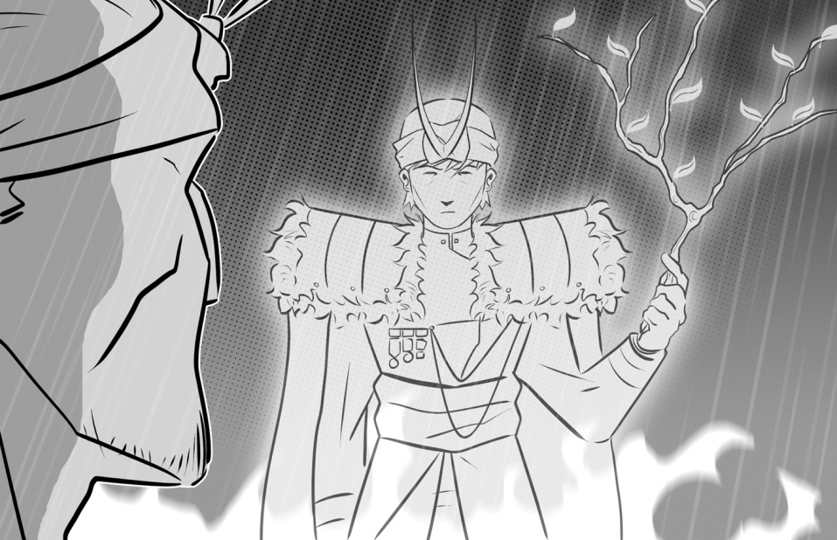

This project and its actions were made possible due to co-financing by the European Fund for the Integration of Third-Country Nationals.

This project and its actions were made possible due to co-financing by the European Fund for the Integration of Third-Country Nationals.

This project and its actions were made possible due to co-financing by the European Fund for the Integration of Third-Country Nationals.



**Act Four: Scene 1**

**The three apparitions**

Match the apparition with the prophecy:

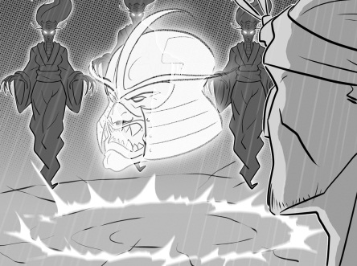

First apparition

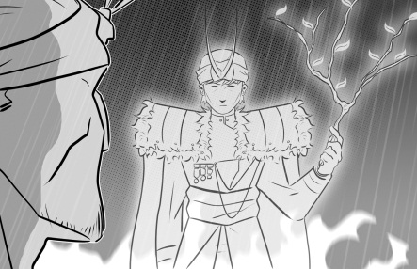

Third apparition

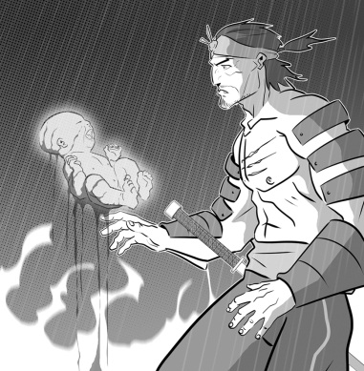

Second apparition

No man born to a woman will harm you!

You won’t be defeated until Birnam Wood comes to Dunsinane Hill.

Be careful of Macduff!

Complete the sentences explaining what the apparitions are and what they say to Macbeth.

1. The first apparition is a _______________________. It tells

Macbeth that he should _____________________________.

1. The second ______________________________________ .

It tells Macbeth that _______________________________

____________________________________________ him.

1. _______________________________________________

_______________________________________________

_______________________________________________.



First apparition



Third apparition



Second apparition

**Act Four: Scenes 1 and 2**

**Macbeth, Macduff and Lady Macduff**

Use the substitution table to write some sentences about Macbeth, Macduff and Lady Macduff in these scenes.

|  |  |  |  |  |
| --- | --- | --- | --- | --- |
| Macbeth  Macduff  Lady Macduff | has  is | run away | that  to  by | England. |
| sent some men | her husband has run away. |
| angry | kill all of Macduff’s family. |
| killed | Macbeth’s men. |
| warned | a messenger to run away. |

1. _________________________________________________

_________________________________________________

1. _________________________________________________

_________________________________________________

1. _________________________________________________

_________________________________________________

1. _________________________________________________

_________________________________________________

1. _________________________________________________

_________________________________________________

**Act Four: Scene 3**

**Comparing Macduff and Malcolm**

Fill in the Venn diagram to show which words and phrases from the box below describe Macduff, Malcolm or both of them.

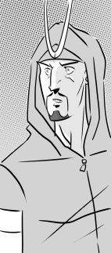

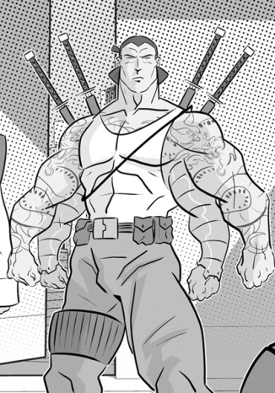

Macduff

talk about events in Scotland do not trust each other at first devastated has gathered an army to fight Macbeth think Malcolm is the true King of Scotland wife and children killed by Macbeth decides to go back to Scotland to fight

Malcolm