

|  |
| --- |
| Macbeth Act 4 |

|  |  |
| --- | --- |
| **Scene summaries** | |
| Subject: | **English** |
| Age range: | **10–12, 12–14** |
| Topic: | **Macbeth** |

EAL Nexus resource

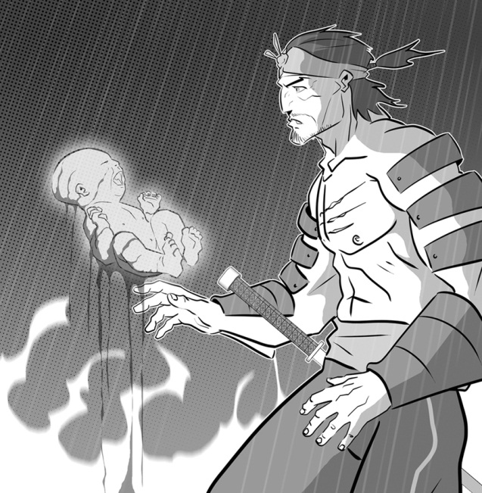

This project and its actions were made possible due to co-financing by the European Fund for the Integration of Third-Country Nationals.

This project and its actions were made possible due to co-financing by the European Fund for the Integration of Third-Country Nationals.

This project and its actions were made possible due to co-financing by the European Fund for the Integration of Third-Country Nationals.

# Macbeth Act 4

## **Scene 1 On the heath**

The three witches and Hecate are preparing a spell and putting lots of horrible things in a cauldron. Macbeth arrives. The witches conjure up apparitions to tell Macbeth what he wants to know.

The first apparition is a head with a helmet. It warns Macbeth to be careful of Macduff. The second apparition is a child covered in blood. The child says that no man born to a woman will be able to harm Macbeth. The third apparition is a child with a crown on its head and a branch in his hand. The child says that Macbeth will not be defeated until Birnam Wood comes to Dunsinane Hill.

Macbeth asks if Banquo’s sons will be kings. Eight kings appear, with Banquo’s ghost.

The witches disappear. Lennox arrives and tells Macbeth that Macduff has run away to England. Macbeth decides to go to Macduff’s castle and kill his wife and all his children.

## **Key words or phrases with pictures**

Birnam Wood a cauldron

a child with a crown on his head and a branch in his hand

a child covered in blood

Dunsinane Hill a head with a helmet

sunset three witches Macbeth

## Key words to translate

|  |  |  |
| --- | --- | --- |
| **Word or phrase** | **Translation** | **Meaning** |
| apparition |  |  |
| to appear |  |  |
| born of a woman |  |  |
| to be careful of |  |  |
| to conjure up |  |  |
| covered in blood |  |  |
| defeated |  |  |
| to disappear |  |  |
| to harm |  |  |
| horrible things |  |  |
| to prepare |  |  |
| spell |  |  |

## **Scene 2 Macduff’s castle at Fife**

Lady Macduff tells Ross that she is angry that Macduff has left her and her children alone and gone to England. Ross leaves. A messenger arrives and warns Lady Macduff to take her children and leave the castle.

A few minutes later the murderers arrive. They kill Lady Macduff’s son. Lady Macduff tries to run away and the murderers run after her.

## **Key words to translate**

|  |  |  |
| --- | --- | --- |
| **Word or phrase** | **Translation** | **Meaning** |
| to chase after |  |  |

**Scene 3 Outside the king’s palace in England**

Macduff is talking to Malcolm about what is happening in Scotland. At first they do not trust each other, but as they are talking they agree that Malcolm is the true King of Scotland. Malcolm tells Macduff that he is gathering an army to fight Macbeth.

Ross arrives from Scotland. He tells Macduff that Macbeth has killed his wife and all his children. Macduff is devastated.

Malcolm decides it is time to take the army and go to Scotland to fight Macbeth.

## **Key words or phrases with pictures**

Malcolm’s army

sunset three witches Macbeth

## Key words to translate

|  |  |  |
| --- | --- | --- |
| **Word or phrase** | **Translation** | **Meaning** |
| to agree |  |  |
| devastated |  |  |
| to gather |  |  |
| it is time to |  |  |
| the true king |  |  |