

|  |
| --- |
| Macbeth for beginners Act 5 |

|  |  |
| --- | --- |
| **Scene summaries** | |
| Subject: | **English** |
| Age range: | **10–12, 12–14** |
| Topic: | **Macbeth** |

EAL Nexus resource

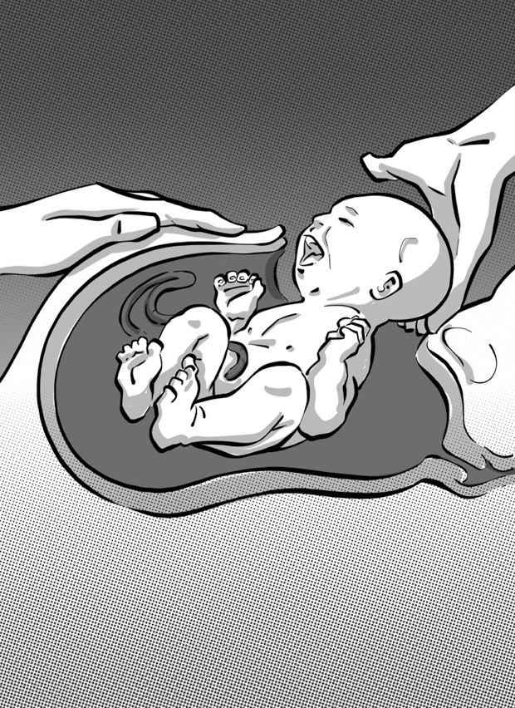

This project and its actions were made possible due to co-financing by the European Fund for the Integration of Third-Country Nationals.

This project and its actions were made possible due to co-financing by the European Fund for the Integration of Third-Country Nationals.

This project and its actions were made possible due to co-financing by the European Fund for the Integration of Third-Country Nationals.

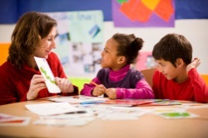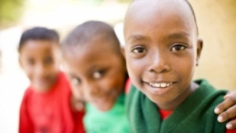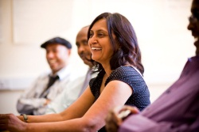

# Macbeth Act 5

## **Scene 1 Macbeth’s castle at Dunsinane**

A doctor and a lady-in-waiting are talking about Lady Macbeth. Lady Macbeth has been sleepwalking and talking in her sleep.

Lady Macbeth appears. She is walking in her sleep. She is rubbing her hands together as if she is washing them. While she is sleepwalking she talks about Duncan’s death, Lady Macduff and her children’s deaths, and the death of Banquo. The doctor says there is nothing he can do to help Lady Macbeth. He says she needs a priest not a doctor.

## **Key words or phrases with pictures**

the doctor a lady-in-waiting

rubbing her hands together

sunset three witches Macbeth

## **Key words to translate**

|  |  |  |
| --- | --- | --- |
| **Word or phrase** | **Translation** | **Meaning** |
| a priest |  |  |
| to need |  |  |
| sleepwalking |  |  |

## **Scene 2 The countryside near Macbeth’s castle at Dunsinane**

Some of the Scottish noblemen and their soldiers arrange to meet Malcolm and the army from England near to Birnam Wood.

## **Key words or phrases with pictures**

some of the Scottish noblemen and their soldiers

sunset three witches Macbeth

## **Key words to translate**

|  |  |  |
| --- | --- | --- |
| **Word or phrase** | **Translation** | **Meaning** |
| to arrange to |  |  |

**Scene 3 Macbeth’s castle at Dunsinane**

Macbeth knows that his enemies are near. He remembers the witches’ prophecies that no man born of a woman can harm Macbeth, and that he will not be defeated until Birnam Wood comes to Dunsinane Hill. Macbeth is very agitated. He asks Seyton to bring his armour. He asks the doctor how Lady Macbeth is. The doctor says she is very restless. Macbeth says he wishes the doctor had some medicine that would defeat the English army. The doctor wants to leave Dunsinane.

## **Key words or phrases with pictures**

Macbeth’s armour medicine

Seyton

sunset three witches Macbeth

## **Key words to translate**

|  |  |  |
| --- | --- | --- |
| **Word or phrase** | **Translation** | **Meaning** |
| his enemies |  |  |
| to remember |  |  |
| restless |  |  |
| to wish |  |  |

**Scene 4 Near Birnham Wood**

The armies from Scotland and England have gathered near Birnam Wood and are preparing to fight Macbeth. Malcolm orders the soldiers to cut branches from the trees and carry them. This is so Macbeth will not be able to see how big the armies are. Malcolm says that the people fighting on Macbeth’s side do not really want to support him.

## **Key words or phrases with pictures**

a branch from a tree

sunset three witches Macbeth

## **Key words to translate**

| **Word or phrase** | **Translation** | **Meaning** |
| --- | --- | --- |
| to carry |  |  |
| to cut |  |  |
| to order |  |  |
| to support |  |  |
| to want to |  |  |

**Scene 5 Macbeth’s castle at Dunsinane**

Macbeth says his castle is strong. He plans to wait inside until his enemies give up and go away.

Seyton arrives and tells Macbeth that Lady Macbeth is dead.

A messenger arrives and tells Macbeth that Birnam Wood looks as if it is moving. It is the English and Scottish armies carrying the tree branches. Macbeth decides to put on his armour and go out and fight bravely.

## **Key words to translate**

|  |  |  |
| --- | --- | --- |
| **Word or phrase** | **Translation** | **Meaning** |
| to give up |  |  |
| strong |  |  |

**Scene 6 Outside Macbeth’s castle at Dunsinane**

Malcolm orders the soldiers to throw down their branches and fight. The battle begins.

## **Key words to translate**

|  |  |  |
| --- | --- | --- |
| **Word or phrase** | **Translation** | **Meaning** |
| to throw down |  |  |
| to begin |  |  |

**Scene 7 Outside Macbeth’s castle at Dunsinane**

Macbeth fights with a young English man called Siward and kills him. Macduff arrives. He is searching for Macbeth.

Siward’s father, Old Siward, arrives and says that the people in the castle have surrendered.

## **Key words or phrases with pictures**

Old Siward

sunset three witches Macbeth

## **Key words to translate**

|  |  |  |
| --- | --- | --- |
| **Word or phrase** | **Translation** | **Meaning** |
| to search for |  |  |
| to surrender |  |  |

**Scene 8 Outside Macbeth’s castle at Dunsinane**

Macbeth and Macduff meet in the middle of the battle. Macbeth tells Macduff that he cannot defeat him, because the witches said that no man born to a woman would be able to harm Macbeth. Macduff says that he was not born to a woman by a normal birth, he was born by a Caesarean section.

They fight and Macduff kills Macbeth.

## **Key words or phrases with pictures**

born by a Caesarean section

sunset three witches Macbeth

## **Key words to translate**

|  |  |  |
| --- | --- | --- |
| **Word or phrase** | **Translation** | **Meaning** |
| in the middle of |  |  |
| a normal birth |  |  |

**Scene 9 Outside Macbeth’s castle at Dunsinane**

Malcolm arrives with his army. Old Siward hears the news that his son is dead.

Macduff arrives, carrying Macbeth’s severed head. He greets Malcolm as King of Scotland.

Malcolm says he is happy that the tyrant, Macbeth, is dead and now Scotland can be free again. He invites everyone to come to his coronation at Scone.

## **Key words or phrases with pictures**

Macbeth’s severed head

sunset three witches Macbeth

## **Key words to translate**

|  |  |  |
| --- | --- | --- |
| **Word or phrase** | **Translation** | **Meaning** |
| coronation |  |  |
| to greet |  |  |
| to invite |  |  |